CSC 170 Lab 14: JavaScript Plugins

Due: Thursday, November 16, 2017

The goal of this lab assignment is to rip-out the simple JavaScript solutions you used on the homepage of your website and replace them with more elegant, jQuery-powered plugins.

You will need to be familiar with these two plugins:

* Super Simple Slider (www.supersimpleslider.com)
* jQuery UI (www.jqueryui.com)

# Setup

* Make a copy of your **lab13** folder. Call it **lab14**
* In the HEAD of *each* HTML file, change the title in the <title> tag to "Lab 13 - …" [1]  
  e.g. <title>**Lab 14** - Shakespeare</title>
* Rip out the "hover trick" JavaScript you used from Lab 13
  + Take the IMG element out of its FIGURE element - delete the FIGURE and FIGCAPTION elements. Just leave IMG under the "Welcome…" H2, by itself.
  + Remove the *onmouseover=""* and onmouseout="" attributes from the IMG
  + Create a second IMG element, right under the first, that points to your other image. (The one you used for your *onmouseover*.)
* Rip out the "More…" JavaScript you used from Lab 13
  + Remove the IDs you used to toggle the content
  + Delete the BUTTON element between your two DIVs
  + Delete the DIVs around your content (leave the content)
  + In the file system, delete the folder and file: **js/scripts.js**
  + In the index file, delete the script link to the **js/scripts.js** file

You'll end up with something that looks like this:  
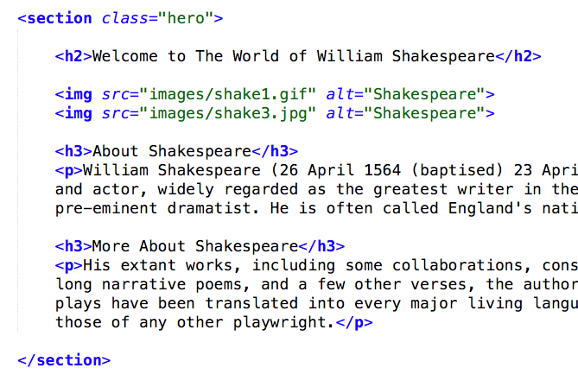

# Install Super Simple Slider

You need to install the plugin according to the instructions by the author. In all, you need to do the following:

* Add the **sss** folder as-is to your **lab14** folder[2]
* In your **index** file, in the correct location add a link to the **sss/sss.css** file  
  <link rel="stylesheet" href="sss/sss.css">
* In your **index** file wrap your IMGs in a new DIV with a class="slider"
* In your **index** file, in the correct location install jQuery

<script src="http://ajax.googleapis.com/ajax/libs/jquery/1.9.0/jquery.min.js"></script>

* In your **index** file, in the correct location install the SSS plugin  
  <script src="sss/sss.min.js"></script>
* In your **index** file, in the correct location install an initialization string for the SSS plugin  
  <script>  
  $('.slider').sss();  
  </script>

# Install jQuery UI's Accordion Plugin

You need to install the plugin according to the instructions by the developers of jQuery UI. In all, you need to do the following:

* NOTE: you must *not* re-install jQuery! (You already installed it when you added SSS.)
* In your **index** file, in the correct location install the plugin script using a CDN that hosts the jQuery UI script

<script src="http://code.jquery.com/ui/1.11.4/jquery-ui.js"></script>

* In your **index** file, in the correct location install an initialization string for the jQuery UI plugin

<script>  
$( "#accordion" ).accordion({

heightStyle: "content"

});

</script>

* Install the CSS using the CDN that hosts the jQuery UI styles

<link rel="stylesheet" href="http://code.jquery.com/ui/1.11.4/themes/smoothness/jquery-ui.css">

* Wrap your content (a couple of headers and some paragraphs) in a new DIV with an id="accordion"

You should end up with something that looks like this:  
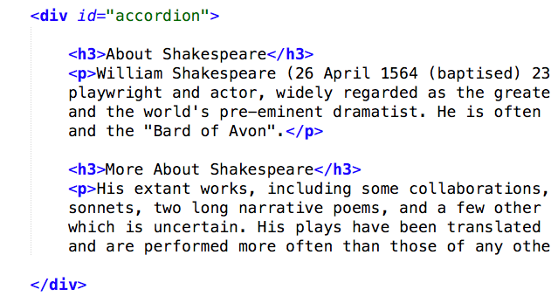

OPTIONALLY: go into your hero.css file and change/add styles as you see fit to make the "hero" look nicer. E.g. add gird-gap: 25px; to the .hero styles. Maybe get rid of the border bottom? It's up to you.

# Check and Upload your Work

* Validate the HTML file (**http://validator.w3.org/**)

When you are done with your webpage, close everything and use an FTP tool (to access your account on **urcsc170.org** and upload your files:

* In a web browser (any), go to this address to check your handiwork:   
  **www.urcsc170.org/*accountname*/lab14/index.html**  
  (where “*accountname*” is your account name)

# Report your work

* In our Blackboard section, in Lab 14, post a link to your webpage to receive credit for this Lab.

1. If you're still using PHP includes, this is a snap!
2. Obtain the SSS folder from the author's website